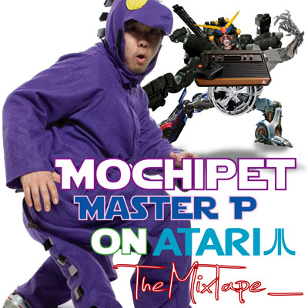

ARTIST: Mochipet
TITLE: Master P on Atari MixTape
CAT-NO: DCM001
FORMAT: Free Digital Digital
RELEASE DATE: 01/13/2009

Not only intended as a teaser to Mochipet’s upcoming full length release “Master P on Atari,” coming out April 7th 2009. This MixTape features never before released exclusives tracks mashed up in an electronic blender only as Mochipet could. There are plenty of 808 Bangers like the ones on his “Microphonepet” release which gained him a spot on NBA2k9 Videogame along side acts such as Beastie Boys, N.E.R.D., and The Cool Kids. But this time, with a much dirtier, bassier sound. We noticed close attention to the Kicks and Snares as they chug along nudged shuffled bass driven beats.

edIT (The Glitch Mob) "Mochi is keepin' it hyphy for the asians."

Lazersword (Briefcase Rockers) “yo man, was just listening to this mochipet track on my itunes a second ago, and was like what the fuck this is the dopest track i've ever heard. that whole album is rawwwwww”

MISSILL ( Paris , France ) “WOW, i didnt take a slap on my face like dat since a while.. wow wickeed album !!!...well done, big respect”

Tracklisting:
01) Boss Dub Pet
02) A Milli Girls Standing in the line for the Bathroom
03) Master P likes Atari
04) Walk it Talk it, Put a Stick in it!
05) R. Kelly is out of The Closet
06) Dubs
07) The Thizzle Dance
08) Missy Ellipet
09) Bobo Loves Dubstep Too.
10) FreeBassing 18lbs of Dub with Marvin Gaye
11) You got your IDM in my Dubstep Again!

Daly City Records, 353 Philip Dr. #306, Daly City, CA 94015, email: info@dalycityrecords.com

