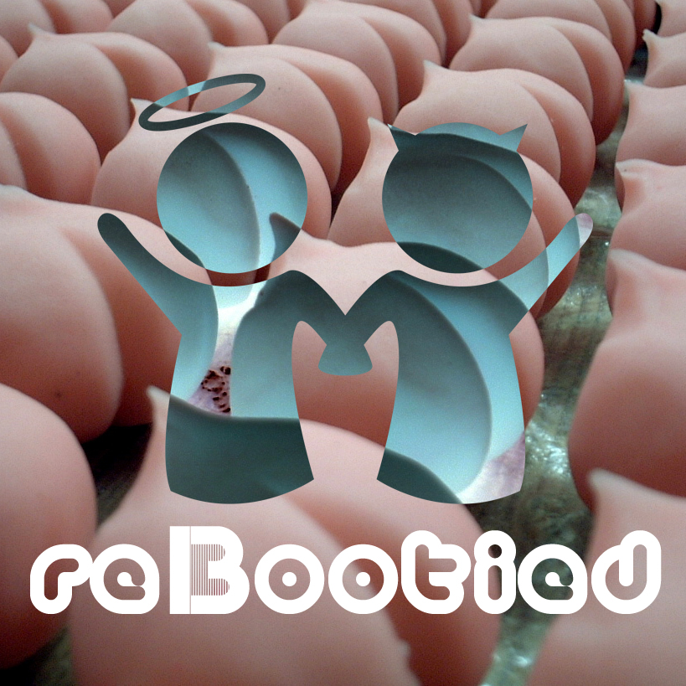
ARTIST: Mochipet
TITLE: reBootied
LABEL: Daly City Records
CAT-NO: DCR138
FORMAT: Digital
RELEASE DATE: 02/10/2009

With the release of Mochipet’s last full length “Microphonepet” we have seen him go in many new directions; Such as a spot on the latest NBA2k9 videogame along side acts such as Beastie Boys, N.E.R.D., and The Cool Kids, A successful European and US tour, appearances in various Movie Soundtracks, Heavy rotation on Seattle’s KEXP, and a nomination for The Best Electronic Act of 2008.

With all this happening, there is no wonder why a remix contest had to be in the works. But with an overwhelming number of entries and so many great remixes, it was very difficult for Mochipet to pick just one. So we see the inception of Mochipet’s “re” series. Hand selected from the remix contest by genre. Daly City Records brings you Mochipet: reBootied (DCR138), reHyphed (DCR139), reTweaked (DCR140), and reCored (DCR141). Now you can hear Mochipet interpreted from artists around the world.

Track Listing:
01) Girls & Boys & Toys (Douster Remix)
02) Banana Split (Octa Push Remix)
03) Girls & Boys & Toys (Bender's Playtime Remix)
04) Girls & Boys & Toys (Copyfokking On Euro Koduro Remix)
05) Girls & Boys & Toys (Krugger Flaps Remix)


douster
Born and raised in Lyon, France Douster started hismusicallife somewhere between the highly broadcasted sound of eurodanceand the 50's rythm n blues tapes that were screaming out the familiarcar. At the early age of 8 he turned into french rap, and hip hop music stayed with him during his life as a teenager. Boughthis first MKII's at the age of 14 to start scratching, but very quicklyhe went into production and started making beats for his friends. Withthe influence of dancehall music and the high powered dub soundsystemhe started to add heavy sub basses to his productions. And when a closefriend of him brought him a crate full of smiley faced vinyl, he feltin love with acid house early 90's newbeat . At 22, he's now trying to make his own kind of house music, mixing his influences to provide that wobbly jackin sound ! From reggae soundsystems to south american clubs,douster always had the sense to entertain crowd, following the oldtradition of Hip Hop Dj's. His dj sets combined a wide range of bassmusic, mixing top notch fidget house, world ghetto music, and classicrave hits. His first release on Birmingham based label A NewHope, 'This Shit', a perfect mix between jackin'house and heavy wobllebass, received a lot of support and Douster is now ready to take over he clubs.

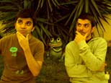
Octa Push
Project born in 2008
These Portuguese brothers from Lisbon, love to play it loud!
Their style takes influence from all over. Grime, Bashment, Dub, Techno, Portuguese, African, Dubstep, Cut and Glitch.. and so. Receiving great feedback for their remixes for Buraka Som Sistema, Jahcoozi, DJ C & MC Zulu, 2009 will be big with some original and remix releases and their debut EP.
www.myspace.com/octapush


Bender
Whether it's a crowd of 10 or 10,000, Bender aka Ben Collins is sure to fill the room with smiling faces and sweaty brows with his unique, unrelenting style of dance floor laser tag. Repping his Kansas City roots to the fullest, this Midwest-coaster brought his rebel assault of original production and handpicked beats to the Bay Area in 2002. Bender hasn't looked back since, watching his rep grow as he collaborates with other beatsmiths including Mochipet and Sleepyhead. His most recent mix, "Kinda Sloppy, Really Wet" (available at www.thebeatregister.blogspot.com) is a testament to Bender's chameleon-like ability to blend beats and create a genre The Beat Register dubbed, "DirtyBassHipGlitchDownHouseDubTempoHop." Easily his most defining mix to date, it is Bender's personal narrative told thru an 80-minute mélange of original production and turntable magic. Bender takes a lifetime of influences from The Cure all the way to Megasoid and puts it together in a package so enticing you can't help your curiosity. For Bender, DJing isn't just fun and games; it's a chance to make every night Christmas for his listeners as he serves up musical eggnog leaving the crowd reeking of vermouth and bass. Within the past year, it's been holiday season every day for Bender as he's shared bills with top-shelf artists including, Flying Lotus, Eliot Lipp, and a slew of others.


COPYFOKKING
“COPYFLEX & JENS FOKKING is COPYFOKKING. Known as COPYFOKKING they
produce & play everything from pop to underground - mixed into a cocktail of
energetic beats, swinging from techno and electro to koduro and baile funk as
well as hip-hop and ghetto-tech. When Copyfokking are out they seem to pull
things in a direction where dj’s to a greater degree get room to be musical at
the same time as the snobbery around pop vs. underground is put on hold in
order to let the various genres compliment each other in a brilliant way. The
boys will burn the soles off whatever you choose to put your feet in.”
– Georg Rasmussen, Head of Bookings, Vega Nightclub, Copenhagen.


KRUGGER FLAPS
Krugger Flaps belong to Paris' electro new school. Through the extensive use of their machines and synthesisers, they have gathered the original party spirit of RocknRoll. Greatly inspired from Electroclash, Electrorock, Newrave, Techno, but also from the best of the eighties, they have created a style that worships the most insane years of RocknRoll on one hand, and the wonders of modern technology on the other. An undeniable sense of groove along with powerful rhythms transform their music in a dancefloor devastating machine which should take care of the chilliest clubber! Krugger Flaps is more than just a music, it's a lifestyle : Sex Champagne and RocknRoll!!

What People are saying about Mochipet:

Artist/DJ Quotes:

Kid Koala (Ninjatune)
“Mochipet is hilariously funky. He should score the next Katamari video game!”

Darko (Ninjatune / BBC / Spank Rock)
“Mochipet, who makes face-melting breakcore music and often performs his live shows wearing a purple dinosaur costume. Breakcore's the type of music that I envision hearing when going to one of those vampire parties from the movie Blade… yo. im listening to this metal mix... WHOA! this is so where Im at right now....”
MISSILL (Paris, France)
“WOW, i didnt take a slap on my face like dat since a while.. wow wickeed album !!!...well done, big respect”

BASSBIN TWINS
“'machinedrum n mochipet' = boh! keep on mochipet “

edIT (The Glitch Mob)
"Mochi, keepin' it hyphy for the asians. Lyrical giants vs. they Might be giants is still the shit!"
Otto Von Schirach (Schematic/Ipecac)
“Traxx Atre fuckin Lush! Hell Yes... They Sound Wicked as Hell, Mama's Breakcore!"

DJ Rupture (Soot)
“Amazing! Obviously a true gentleman.”

Lazersword (Briefcase Rockers)
“yo man, was just listening to this mochipet track on my itunes a second ago, and was like what the fuck this is the dopest track i've ever heard. that whole album is rawwwwww”

FLUOKIDS Pharrell
Mochipet ….soft and pop, slow fox trot, rubs your buttocks more gently please, I want to take my time like turning the first 25 pages of pub of my magazine of mode, mode.

People Get Real - Wax:On
“I can see me playing this to tempt people onto the dancefloor....all good.”

Press Quotes:

URB Magazine
“Mochipet is making one hell of an argument—for hip hop and even music in general….One very versatile producer….a strong roster of guest emcees and bass custom built to move booties of the large persuasion.”

San Francisco Bay Guardian
"Microphonepet" demonstrates that Mochipet is an amazingly skilled producer who can effortlessly shapeshift from his known style to produce one of the best hip-hop albums this year. - Billy Jam

Time Out New York
Forget all that talk about Estelle's "American Boy," this is the song of the summer…Bay Area producer Mochipet capture the perfect summer afternoon..” - Claire Madigan

Clash Magazine (UK)
“Top Electronic Artists of 2008 - Savaged edits over schizphreaked beats sizzled Mochipet’s great album into our charts…talent populated this sonic bullet.”

East Bay Express (Bay Area)
“Shows a knack for innovation that separates Wang from the pack… Wang's ability to keep innovating has given him real staying power in an increasingly fickle electronic music scene. He now belongs to an elite class of Bay Area DJs,” - By Rachel Swan

Toph One (XLR8R)
“keep an ear on that Mochipet character–his shit is DOPE.”

Asian American Film Festival
“A mind-melding face-off, connecting the dots between hip hop, IDM, jazz, and more…”

SF Weekly (San Francisco)
“I have lost control... these musicians are all bound by the fact that there's little binding them, except, perhaps, a guiding sense of fuck-'em-if-they-can't-take-a-joke irreverence, an unpracticed and infectious weirdness. they don't fit in, but that's exactly why it's working. - Jonathan Zwickel

Raveline.de
“A Pikachu is in the disco!”

