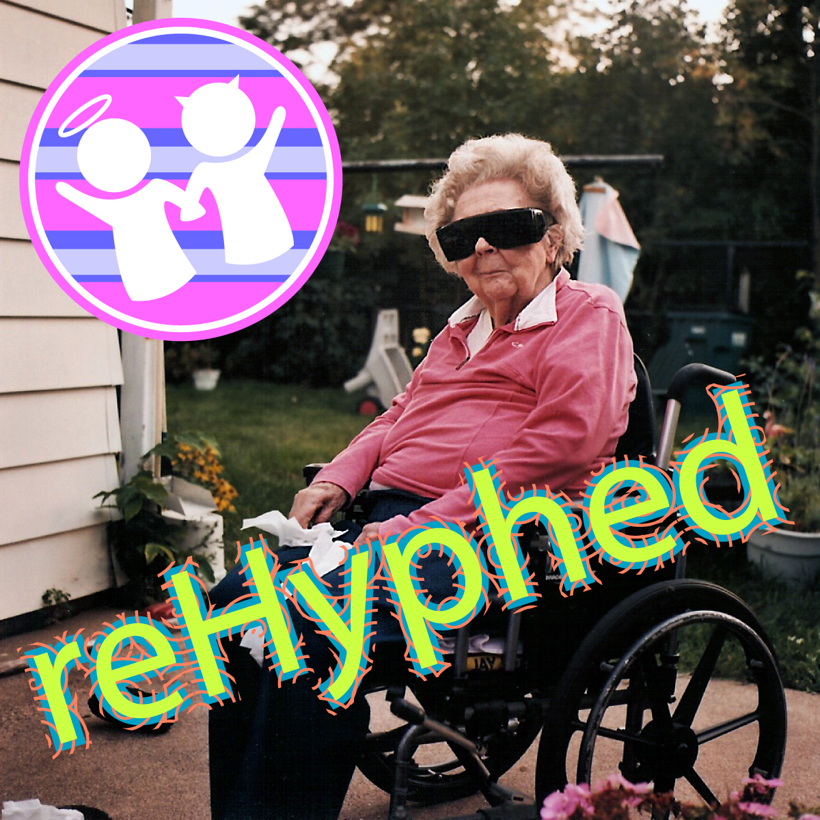

ARTIST: Mochipet
TITLE: reHyphed
Label: Daly City Records
CAT-NO: DCR139
FORMAT: Digital and Limited Edition CDs
RELEASE DATE: April, 14, 2009

With the release of Mochipet’s last full length “Microphonepet” we have seen him go in many new directions; Such as a spot on the latest NBA2k9 videogame along side acts such as Beastie Boys, N.E.R.D., and The Cool Kids, A successful European and US tour, appearances in various Movie Soundtracks, Heavy rotation on Seattle’s KEXP, and a nomination for The Best Electronic Act of 2008.

With all this happening, there is no wonder why a remix contest had to be in the works. But with an overwhelming number of entries and so many great remixes, it was very difficult for Mochipet to pick just one. So we see the inception of Mochipet’s “re” series. Hand selected from the remix contest by genre. Daly City Records brings you Mochipet: reBootied (DCR138), reHyphed (DCR139), reTweaked (DCR140), and reCored (DCR141). Now you can hear Mochipet interpreted from artists around the world.

Track Listing:
01) Hope Again - Featuring Mykah9 and Taiwankid (edIT reMash)
02) Girls and Boys and Toys - Featuring Jahcoozi (Salva Remix)
03) Banana Split - Featuring E da Boss & Bicasso of Living Legends (Vladimir Computin Remix)
04) Banana Split - Featuring E da Boss & Bicasso of Living Legends (Leo Nevilo Remix)
05) Tangle - Featuring Salva and Epcot (Matt B Remix)
06) The Graduate - Featuring Dubphonics (Tony Oheix Remix)

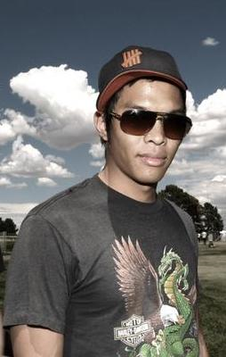
edIT (The Glitch Mob)
When four friends, Ooah, edIT, Boreta & Kraddy all noted fixtures on the West Coast underground team up with a creative vision and positive intentions the result is A relentless sonic assault on the dance floor of ferocious drums, catastrophic sub bass, and sounds from another world It is an unforgiving and punishing physical audio experience that will leave your body beat to the core and your soul wanting more It is the gift of music from this four man collaboration with the intention to unite the masses on the dance floor through trying times It is the experience of being slayed......
The Glitch Mob


Salva (FriteNite)
Paul Salva plays keyboards and types on his keyboard. You can call him by his last name. If you know him you will call him funny names. He is a descendant of the Roman empire but that's now why he's famous. His record label is called Frite Nite. His musical band is called The Vanishing System. You can book him to play synthesizers and play vinyl records, or maybe to do work for his day job on his laptop on stage and pretend that he's making music. Please contact bookings@fritenite.com to engage in a contractual obligation with this performer for entertainment services. Download Salva's old DJ mix. He'll make a new one when he feels like it, god.

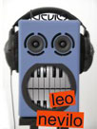
Nevilo
at the tender age of 4 i bought 10 turntables from the money i got from mowing my neighbour's carpet, practiced 20 hours a day and realized that every other bio started with the same sentence. at 5, with only 1 zimbabwe dollar in my pocket, i left my hometown for new york, where i was unable to finish this sentence because i ran out of ideas. my scratching skills are widely recognized and beloved, although only by the dogs in my neighbourhood.
all songs on the player are available for download! click on the blog above or go to my homepage on the left! if you want to contact me, but don't have a myspace account, just go to my hompeage and you can send me an email from there!

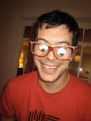
Vladimir Computin (Serato, Daly City)
Born and raised in Weston, Massachusetts, Bill Mitsakos, began making noise in the mid 90s with school bus co-passenger Edward Ma (a.k.a. edIT). He moved to San Francisco in 2000 where he linked up with producer J.Tonal and began DJing the legendary Lowpro Lounge parties under the alias Brizzlescratch. In 2003 he met prolific jazz musician Evan Francis and the two began recording tracks together. These recordings would ultimately result in the critically acclaimed 2006 release of Spaceheater’s “The Record”. In late 2006 Mitsakos moved to Auckland, New Zealand to design hardware and software for Serato Audio Research. In July 2008 he returned to San Francisco sporting a new pimp-handle inspired by Russian prime-mobster Vladimir Putin. 2009 will prove a busy year for Vladimir Computin… A forthcoming remix EP with re-workings of tracks by mochipet, edIT, the flying skulls, and others. A new club night at Madrone Lounge in San Francisco. Mitsakos is also curator of Serato Pressings, a revolutionary new hybrid vinyl record label with forthcoming co-branded releases on labels such as Mad Decent, Ninja Tune, and Stones Throw. Befriend him at http://www.myspace.com/vladimircomputin

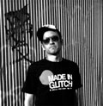
mattB (Bass Science, Made in Glitch)
Bass Science fuses dubstep, glitch hop, IDM and dub into a fresh new sound that is simultaneously filthy and extremely clean. In less than a year since their inception, they have created a prolific body of work and electrified dancefloors across the globe: call it glitchstep, call it dubhop, call it what you will, Bass Science’s hybrid sounds are generating a cabinet-rattling buzz. Based between Tokyo and Los Angeles, the duo of MattB and Steve Nalepa has quickly earned a reputation for their powerful live show: in short order, they’ve dazzled crowds at seminal festivals like UK’s Glade and Los Angeles’ Low End Theory, with globetrotting gigs spanning Asia, Europe and the US. Bass Science’s tracks, meanwhile, have received enthusiastic support from influential DJs like the BBC’s Mary Anne Hobbs and Annie Nightingale, Resonance FM’s Nick Luscombe, with regular rotation on Dubstep.FM. With remixes in the works for Adam Freeland and Evil Nine, vinyl EPs due out on Elektrik Dragon and Detroit Underground, and upcoming releases on Blood Tribe Records and Combat Recordings’s new imprint Bankai Audio, Bass Science is blowing up, and not just speakers.


Tony Oheix
Saturated beats, vomiting basses, granular synthesis : TONY OHEIX (co-founder of the label Les Diks Qui Sautent) wants you to discover his style, the Glitch Hop, which is a mix of Glitch and Hiphop ! Influenced by the new Californian scene - The glitch mob, Edit, Kraddy… but also Funkstorung / Prefuse 73 - the producer distinguishes himself with this project, based on a very personal and messy crazy style!

What People are saying about Mochipet:

Artist/DJ Quotes:

Kid Koala (Ninjatune)
“Mochipet is hilariously funky. He should score the next Katamari video game!”

Darko (Ninjatune / BBC / Spank Rock)
“Mochipet, who makes face-melting breakcore music and often performs his live shows wearing a purple dinosaur costume. Breakcore's the type of music that I envision hearing when going to one of those vampire parties from the movie Blade… yo. im listening to this metal mix... WHOA! this is so where Im at right now....”
MISSILL (Paris, France)
“WOW, i didnt take a slap on my face like dat since a while.. wow wickeed album !!!...well done, big respect”

BASSBIN TWINS
“'machinedrum n mochipet' = boh! keep on mochipet “

edIT (The Glitch Mob)
"Mochi, keepin' it hyphy for the asians. Lyrical giants vs. they Might be giants is still the shit!"
Otto Von Schirach (Schematic/Ipecac)
“Traxx Atre fuckin Lush! Hell Yes... They Sound Wicked as Hell, Mama's Breakcore!"

DJ Rupture (Soot)
“Amazing! Obviously a true gentleman.”

Lazersword (Briefcase Rockers)
“yo man, was just listening to this mochipet track on my itunes a second ago, and was like what the fuck this is the dopest track i've ever heard. that whole album is rawwwwww”

FLUOKIDS Pharrell
Mochipet ….soft and pop, slow fox trot, rubs your buttocks more gently please, I want to take my time like turning the first 25 pages of pub of my magazine of mode, mode.

People Get Real - Wax:On
“I can see me playing this to tempt people onto the dancefloor....all good.”

Press Quotes:

URB Magazine
“Mochipet is making one hell of an argument—for hip hop and even music in general….One very versatile producer….a strong roster of guest emcees and bass custom built to move booties of the large persuasion.”

San Francisco Bay Guardian
"Microphonepet" demonstrates that Mochipet is an amazingly skilled producer who can effortlessly shapeshift from his known style to produce one of the best hip-hop albums this year. - Billy Jam

Time Out New York
Forget all that talk about Estelle's "American Boy," this is the song of the summer…Bay Area producer Mochipet capture the perfect summer afternoon..” - Claire Madigan

Clash Magazine (UK)
“Top Electronic Artists of 2008 - Savaged edits over schizphreaked beats sizzled Mochipet’s great album into our charts…talent populated this sonic bullet.”

East Bay Express (Bay Area)
“Shows a knack for innovation that separates Wang from the pack… Wang's ability to keep innovating has given him real staying power in an increasingly fickle electronic music scene. He now belongs to an elite class of Bay Area DJs,” - By Rachel Swan

Toph One (XLR8R)
“keep an ear on that Mochipet character–his shit is DOPE.”

Asian American Film Festival
“A mind-melding face-off, connecting the dots between hip hop, IDM, jazz, and more…”

SF Weekly (San Francisco)
“I have lost control... these musicians are all bound by the fact that there's little binding them, except, perhaps, a guiding sense of fuck-'em-if-they-can't-take-a-joke irreverence, an unpracticed and infectious weirdness. they don't fit in, but that's exactly why it's working. - Jonathan Zwickel

Raveline.de
“A Pikachu is in the disco!”

