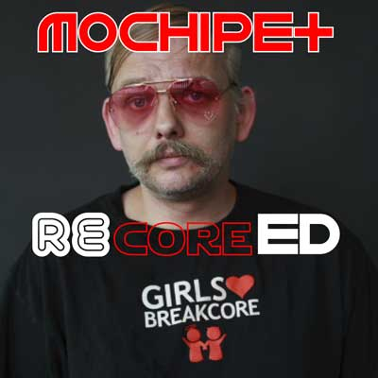

ARTIST: Mochipet
TITLE: reCored
Label: Daly City Records
CAT-NO: DCR141
FORMAT: Digital and Limited CDs
RELEASE DATE: 4/28/2009

With the release of Mochipet’s last full length “Microphonepet” we have seen him go in many new directions; Such as a spot on the latest NBA2k9 videogame along side acts such as Beastie Boys, N.E.R.D., and The Cool Kids, A successful European and US tour, appearances in various Movie Soundtracks, Heavy rotation on Seattle’s KEXP, and a nomination for The Best Electronic Act of 2008.

With all this happening, there is no wonder why a remix contest had to be in the works. But with an overwhelming number of entries and so many great remixes, it was very difficult for Mochipet to pick just one. So we see the inception of Mochipet’s “re” series. Hand selected from the remix contest by genre. Daly City Records brings you Mochipet: reBootied (DCR138), reHyphed (DCR139), reTweaked (DCR140), and reCored (DCR141). Now you can hear Mochipet interpreted from artists around the world.

Track Listing:
01) Girls & Boys & Toys (NastyNasty Tits & Asscot Mix)
02) Lazy Day (Preshish Moments Remix)
03) Girls & Boys & Toys (The Fez Remix)
04) Girls & Boys & Toys (Deleete Remix)


NastyNasty
Jasper Reeder (AKA build128, nails, fivenotsix, etc...) has been sharpening his teeth over the last few years on warehouse crowds, dancefloors and various clubs around the bay area. A self proclaimed sound molester, build128 performs genre bending live sets ranging spanning from droning ambient monstrosities to high speed rave-core abominations. With deep rooted hip-hop and punk influences Jasper specializes in making aggresive, hyper melodic music with deep atmospheres and snarling sound design.

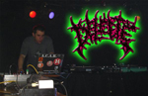
Deleete
1995-2000: Deleete became an analogue freak! 'I've got tr808, tb303, mc202, only analogue gear…and a Atari 1040 st'. Play at his first Acid Party under name of Lee Sergikx, style was Acidcore, Hard Techno. production of several records. DJing in a lot of local party, all over Europe and once in New York in 2001. Organisation of many Acidcore parties on his area with the Lokal Bass Crew. (Some parties left people traumatised) 2001: Different music different name, Deleete is born, start to produce, Breakcore, Industrial, Breaks, TrashcoreDeleete is still involved with organisation or support for a bunch of independant party NOW: Performing live acts or Dj wh laptop , effects and strange boxes, experimentation in all kind of 'core'.

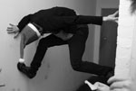
The Fez

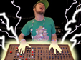
Preshish Moments
Preshish Moments is the cuddly demon-seed of Michael Carter and the winner of the 2007 San Francisco Laptop & Machine Music Battle. Hailing from Berkeley, CA, Preshish Moments builds unique instruments for the performance of electronic music. He devours hip-hop, house, jungle, pop, rock, hardcore, breakcore n' more, and vomits out a rainbow of offbeat melodies and skittering drums.

What People are saying about Mochipet:

Artist/DJ Quotes:

Kid Koala (Ninjatune)
“Mochipet is hilariously funky. He should score the next Katamari video game!”

Darko (Ninjatune / BBC / Spank Rock)
“Mochipet, who makes face-melting breakcore music and often performs his live shows wearing a purple dinosaur costume. Breakcore's the type of music that I envision hearing when going to one of those vampire parties from the movie Blade… yo. im listening to this metal mix... WHOA! this is so where Im at right now....”
MISSILL (Paris, France)
“WOW, i didnt take a slap on my face like dat since a while.. wow wickeed album !!!...well done, big respect”

BASSBIN TWINS
“'machinedrum n mochipet' = boh! keep on mochipet “

edIT (The Glitch Mob)
"Mochi, keepin' it hyphy for the asians. Lyrical giants vs. they Might be giants is still the shit!"
Otto Von Schirach (Schematic/Ipecac)
“Traxx Atre fuckin Lush! Hell Yes... They Sound Wicked as Hell, Mama's Breakcore!"

DJ Rupture (Soot)
“Amazing! Obviously a true gentleman.”

Lazersword (Briefcase Rockers)
“yo man, was just listening to this mochipet track on my itunes a second ago, and was like what the fuck this is the dopest track i've ever heard. that whole album is rawwwwww”

FLUOKIDS Pharrell
Mochipet ….soft and pop, slow fox trot, rubs your buttocks more gently please, I want to take my time like turning the first 25 pages of pub of my magazine of mode, mode.

People Get Real - Wax:On
“I can see me playing this to tempt people onto the dancefloor....all good.”

Press Quotes:

URB Magazine
“Mochipet is making one hell of an argument—for hip hop and even music in general….One very versatile producer….a strong roster of guest emcees and bass custom built to move booties of the large persuasion.”

San Francisco Bay Guardian
"Microphonepet" demonstrates that Mochipet is an amazingly skilled producer who can effortlessly shapeshift from his known style to produce one of the best hip-hop albums this year. - Billy Jam

Time Out New York
Forget all that talk about Estelle's "American Boy," this is the song of the summer…Bay Area producer Mochipet capture the perfect summer afternoon..” - Claire Madigan

Clash Magazine (UK)
“Top Electronic Artists of 2008 - Savaged edits over schizphreaked beats sizzled Mochipet’s great album into our charts…talent populated this sonic bullet.”

East Bay Express (Bay Area)
“Shows a knack for innovation that separates Wang from the pack… Wang's ability to keep innovating has given him real staying power in an increasingly fickle electronic music scene. He now belongs to an elite class of Bay Area DJs,” - By Rachel Swan

Toph One (XLR8R)
“keep an ear on that Mochipet character–his shit is DOPE.”

Asian American Film Festival
“A mind-melding face-off, connecting the dots between hip hop, IDM, jazz, and more…”

SF Weekly (San Francisco)
“I have lost control... these musicians are all bound by the fact that there's little binding them, except, perhaps, a guiding sense of fuck-'em-if-they-can't-take-a-joke irreverence, an unpracticed and infectious weirdness. they don't fit in, but that's exactly why it's working. - Jonathan Zwickel

Raveline.de
“A Pikachu is in the disco!”

