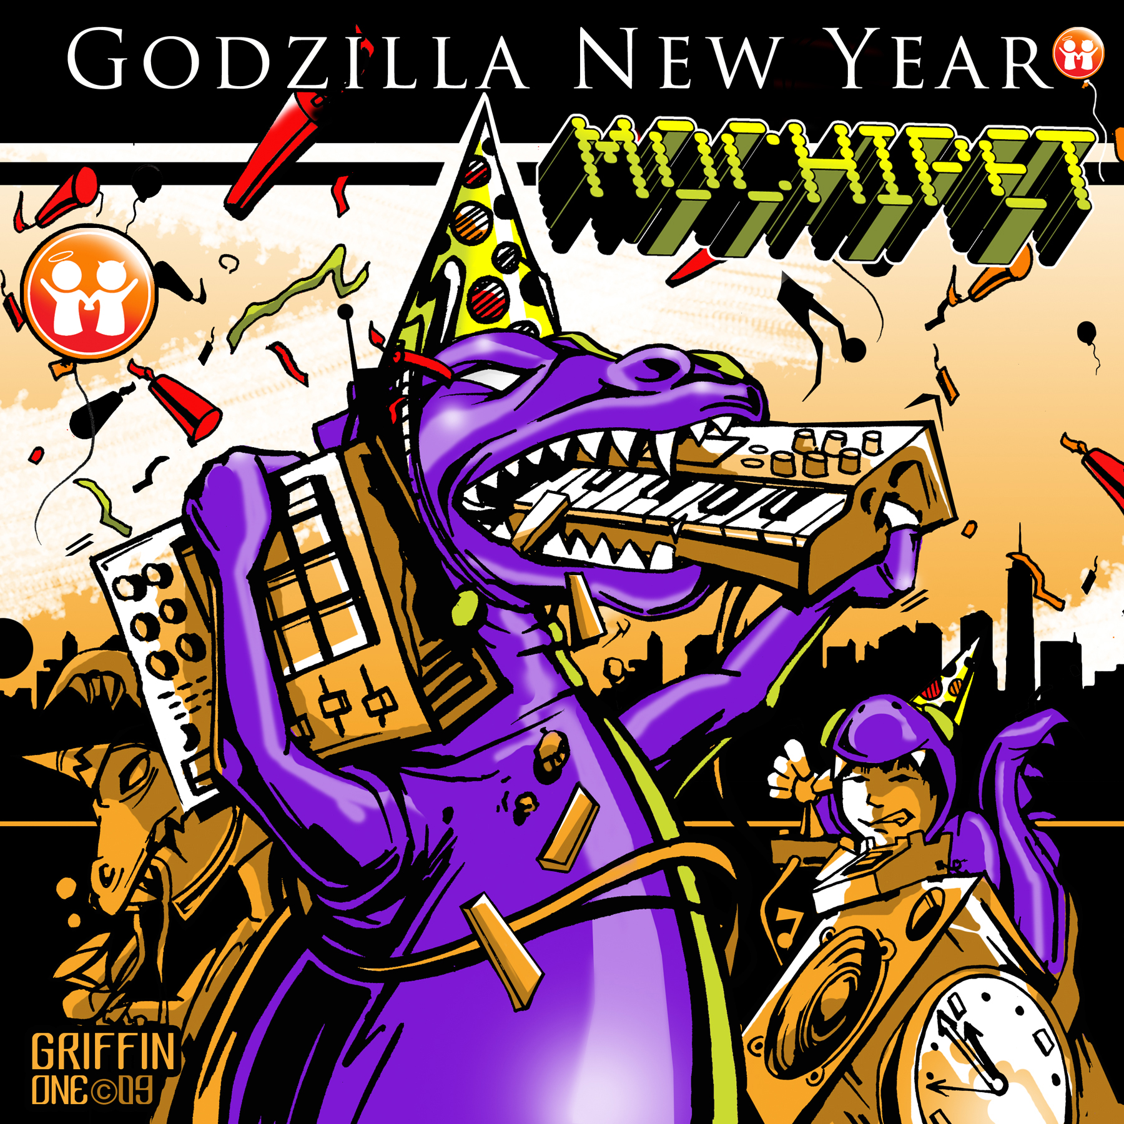

ARTIST: Mochipet
TITLE: Godzilla New Year Single
LABEL: Daly City Records
CAT-NO: DCR142
FORMAT: Digital Single with Remixes
RELEASE DATE: 08/04/2009
COVER ART BY: Sean Griffin

Godzilla New Year is the second single off of Mochipet’s new Epic Glitch’d Out Bass Crunk Anthem, Master P on Atari, released earlier this spring. It combines elements of ethnic Chinese instruments mixed with Street ready Bass Heavy Hip-Hop thrown into a Nintendo 8-bit blender ripped on slow-mo. The beasts are low and chunky and the gongs are bassy and sexy. This release also features remixes by some of glitch and bass’ finest: VibeSquad, Ana Sia, An-ten-nae, and Mimosa, as well as a re-treatments by Mexico’s own Nortec Collective (Clorofila) and Six Degrees Record’s own David Starfire. The combination of styles and cultures are unprecedented, but flows along beautifully to make a surprisingly coherent release. Look for a special Godzilla vs. Mochipet video out soon by the visual media hacker team Savage Henry.

Tracklisting:
01) Godzilla New Year Original
02) Godzilla New Year (Vibesquad Remix)
03) Godzilla New Year (An-Ten-Nae Remix)
04) Godzilla New Year (Ana Sia Remix)
05) Godzilla New Year (Mimosa Remix)
06) Godzilla New Year (Nortec Remix)
07) Godzilla New Year (David Starfire Remix Instrumental)
08) Godzilla New Year (David Starfire Remix Featuring iCatching)

Daly City Records, 353 Philip Dr. #306, Daly City, CA 94015, email: info@dalycityrecords.com
MORE ON THE REMIXERS:

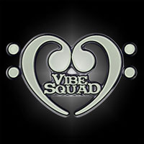
VibeSquad
VibeSquad is the multi-personality brainchild of Aaron Holstein. With releases on NativeState, Proboscis, Interchill, Muti, and Sonic Dragon (Hong Kong) in 2007 alone VibeSquad is quickly emerging as a top producer in the west coast US electronic music scene. Both 2007 EPs "Return of The Pudding People" & "Songs to Accompany Dance Move: The Worm" have been making there way around the globe showing up in DJ’s sets and causing serious mayhem on dancefloors. Though his legendary live sets may cause whiplash and heart attacks in the unsuspecting bystander, those prepared to launch get much more than they bargained for. Aaron’s music defies typical genre-labels and covers tempos from slow ’n hard lowriding krunkadelics to mid-tempo barnstormers all in a seamlessly flowing soulful mash- dirty and beautiful as life itself. Aaron also plays bass/keys for the bands ZILLA (w/ Michael Travis & Jamie Janover) & SPORQUE (w/Ooah & Jamie Janover)


Ana Sia
Ana Sia’s love of electronic music combined with an innate understanding of the value of dance to the human soul collectively fuse to create unforgettable sets of experience, whether she is slamming spots in her hometown of San Francisco or taking her turn in the forests of music festivals around the country. Uniting the best elements of dirty dubstep, grimy glitch, and her personalized blend of “global slut psy-hop,” Ana Sia’s sets confirm crunk status of all who dare enter into her seamless world of sound.
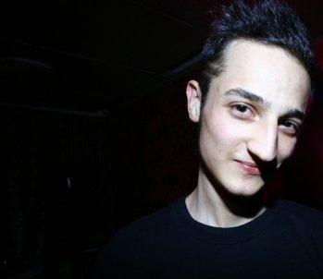
Mimosa
Mimosa takes listeners on a journey through warm rhythmic sound-scapes, with melodies and vocal samples smoothly crafted to help navigate the sonic terrain. Using basslines inspired by hip-hop classics like Too Short and Dr Dre, combined with deep psychedelic textures reminiscent of the downtempo and midtempo output by Tipper and Bluetech, Mimosa blends the range of styles to create his own fresh take on the west coast sound.

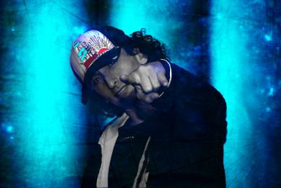
An-ten-nae
an-ten-nae aka Adam Ohana, hails from The Yay Area, The Acid Crunk capitol of the world, and is one of San Francisco's most sought after DJs and live performers. Adam has been DJ’ing and producing electronic music for over 10 years and has been an instrumental part of the underground music culture in SF. His an-ten-nae Presents events, has hosted such artists as Skream, Flying, Lotus, Si Begg, Glitch Mob, Rusko, Moderat, Modeselektor, Diplo he is also Music director of San Francisco's super-club Ten15 Folsom. Over the years Adam has released under many guises and has been featured on such labels as , Marine Parade, Functional Breaks, Muti Music etc.. His latest series Acid Crunk on Muti Music has been receiving world acclaim and we dont see him slowing down anytime soon.

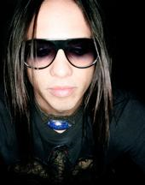
David Starfire
David Starfire is a producer, composer, multi-instrumentalist and DJ based in Los Angeles and San Francisco. His production style is eclectic, fusing music varying from Dance to Rock, Hip Hop to World music and everything in between. David is signed with the internationally known label Six Degrees Records, home to artists such as The Orb, Bebel Gilberto, Banco De Gaia, Cheb i Sabbah, Karsh Kale, Midival Punditz, Michael Franti, DJ Spooky and many others. His tunes have been played on BBC, NPR, National Geographic, XM radio and various stations around the world. The songs merge world instruments with vocals in Hindi, Punjabi, English and incorporating dance and hip hop beats to create an exciting new modern worldly sound.

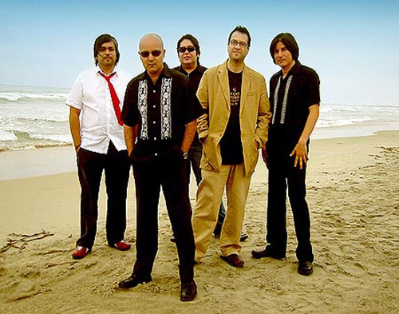
Nortec Collective (Clorofila)
The group formed by the different individual projects who create Nortec music. As a complement, there's also a "Colectivo Visual" a group of designers and VJs who take care of the visual side of Nortec live shows. The term Nortec is a conjunction of Norteño ("of" or "from the North") and Techno, but mainly describes the collision between the music, style and culture of electronic music with those of norteño and tambora, two music genres indigenous to the North of Mexico. These styles are caracterized by their use of accordions and double bass (norteño ); tubas, clarinets, horns and pumping bass drums ( tambora ) and quirky use of percussion and polyrhytmic snare drum rolls (both). All of these elements are used to create a sound that is very Tijuana.
Nortec originated in 1999 when Pepe Mogt, started by experimenting with samples of old banda sinaloense and norteño albums and altering them on his computer or filtering them with analog synthesizers. He had picked up on the idea by listening to the percussive and angular grooves of the tambora and norteña music played at a family social event. Through some contacts in recording studios located in Tijuana's notorious Zona Norte red light district, Pepe compiled tracks of isolated instruments from multitrack recording of tambora and norteño demo recordings that had been abandoned at the studios by the bands that recorded them. He began to burn these tracks onto CD-Rs, which he would later distribute to friends under the condition that they make a new track using the material. Those first raw tracks were compiled onto the "Nor-tec Sampler", the first release from Mil Records followed by the release "The Tijuana Sessions Vol.1" and now the new "Tijuana Sessions vol. 3"

