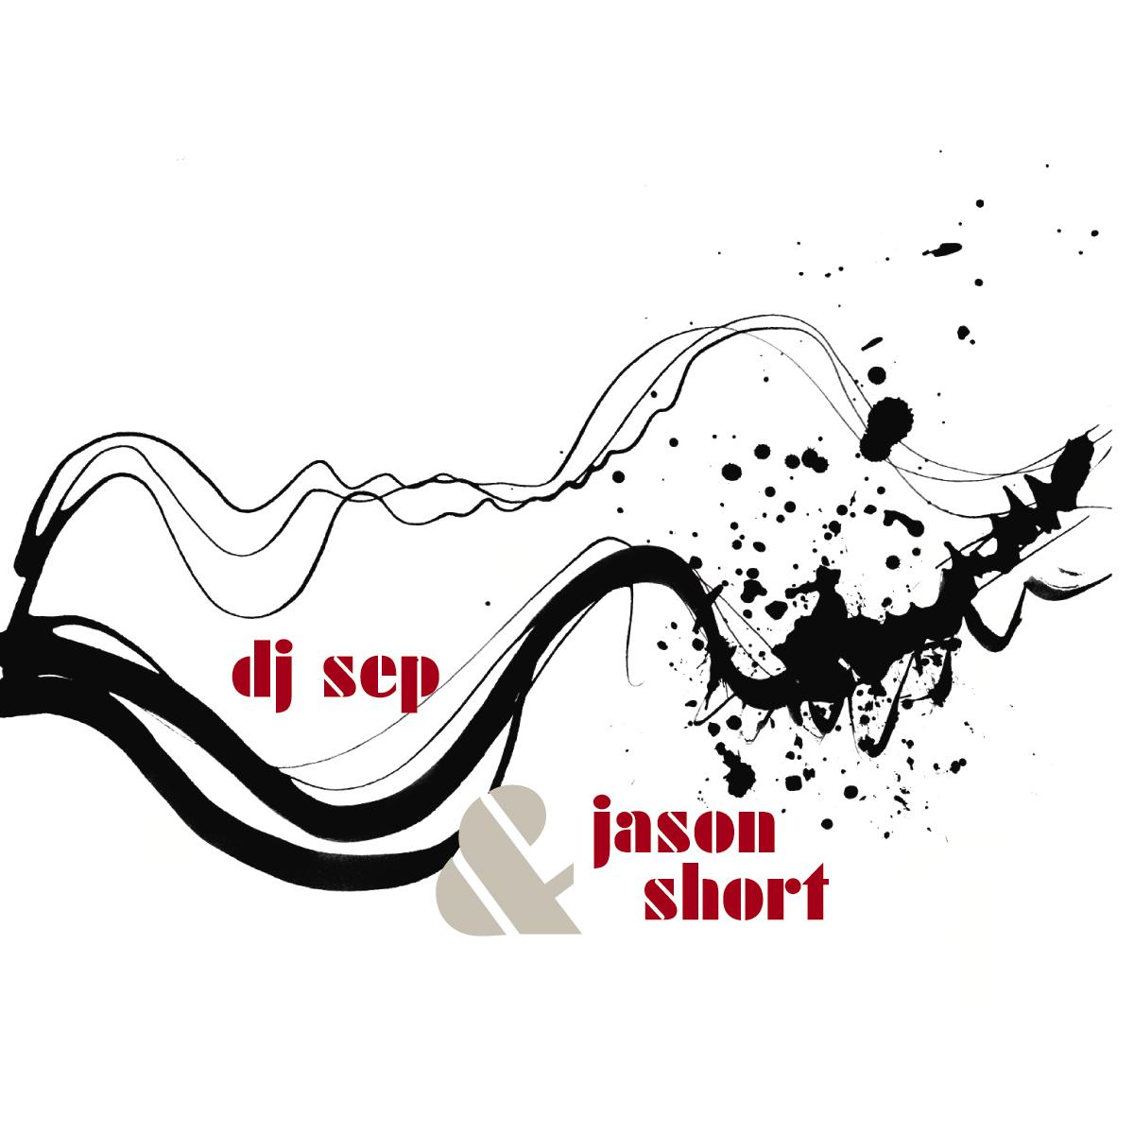

ARTIST: Mochipet, DJ Sep, Jason Short, DJ Collage, Juakali
TITLE: Get Your Dub Wet
LABEL: Daly City Records
CAT-NO: DCR143
FORMAT: Digital Single/Remixes
RELEASE DATE: 09/08/2009
COVER ART BY: Olivia Ting

When the long standing Dub Mission Resident DJ Sep first approached Mochipet to do a Dub rendition of his tune “Get Your Whistle Wet” off of his 2008 Release “Microphonepet” he was honored. But little did he know she would recruit the help of fellow artists Jason Short, DJ Collage, and Juakali. The result is a mending of both Dub and Techno pulling from both Sep and Short’s backgrounds. You add that with the vocal stylings of DJ Collage and Juakali and the end result is nothing short of Bass Heavy, Tech Bouncing Goodness. This is for the lovers of Dub and Glitch Basslines. Read more about DJ Sep, Jason Short, DJ Collage, and Juakali below.

Tracklisting:
01) Get Your Whistle Wet (DJ Sep & Jason Short Dub Mix Featuring DJ Collage)
02) Get Your Whistle Wet (DJ Sep & Jason Short Dub Mix Featuring Juakali)

Daly City Records, 353 Philip Dr. #306, Daly City, CA 94015, email: info@dalycityrecords.com
MORE ON THE CONTRIBUTORS:

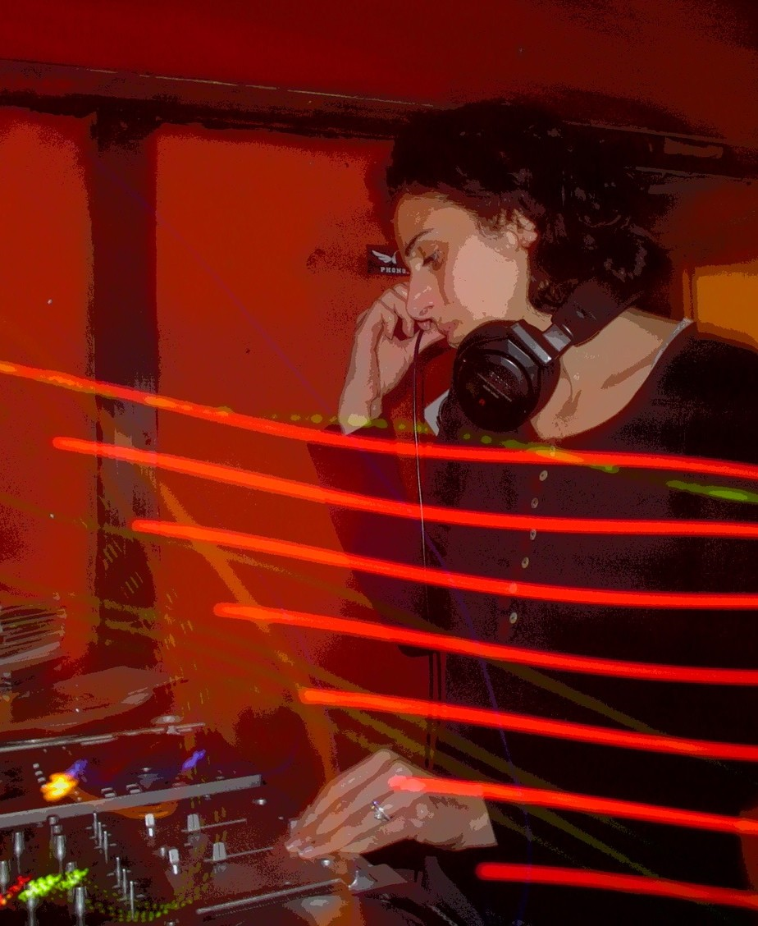
DJ Sep
A DJ, producer, and promoter based in the San Francisco Bay Area, DJ Sep spins dub, dubstep, reggae, dancehall, and electronic dance music influenced by the Middle East, India, Africa, and the Americas. She is the founder, promoter, and main resident DJ at Dub Mission, one of the longest running dub & reggae parties in the U.S., possibly the world. A weekly Sunday night party based in San Francisco, Dub Mission presents cutting-edge dub, roots reggae, dancehall and dubstep, and will celebrate its 13th anniversary in September 2009. Dub Mission has featured artists from all over the world, including Mad Professor, Adrian Sherwood, Twilight Circus Dub Sound System, and The Scientist to name a few. In 1999, Dub Mission won a Bay Guardian Goldie award in the music category. DJ Sep has also been nominated for an SF Weekly Music Award in the best DJ category, and has spun at venues and clubs in London, New York, Los Angeles, Miami, and throughout the Bay Area. In May 2003, she and journalist/DJ Ron Nachmann aka Shockman realized and compiled Babylon Is Ours: The USA in Dub, (www.dubmissionsf.com/theusaindub.html), a compilation of exclusive American dub tracks released by Germany’s Select Cuts Records. Her current radio program, "Off The Beaten Path," is a mix of many forms of electronic music, and airs Monday nights on KPFA (94.1 FM or www.kpfa.org) from 10 pm to midnight West Coast time. DJ Sep has opened for a wide array of artists including Sly & Robbie, Kruder & Dorfmeister, Les Nubians, Rachid Taha, AfroCelt Sound System, Transglobal Underground, Angelique Kidjo, The Cinematic Orchestra, Culture, Big Youth, Nortec Collective, and Issa Bagayogo. For more information, please visit:
www.myspace.com/djsepmusic
http://www.dubmissionsf.com
http://kpfa.org/beaten-path

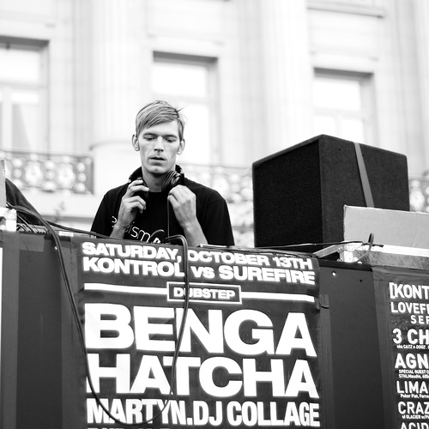
Jason Short [Auralism :: Karloff Recordings :: Nightlight] is young, tirelessly enthusiastic, and stands as one of San Francisco's emerging techno DJ/producers in a scene gaining international recognition for new sounds and fresh directions. He didn't arrive here by accident though; it is literally a decade's worth of hard work in the making. The resourceful Short is the co-founder of the popular San Francisco label Auralism as well as one half the production duos Coalition of the Killing (COTK), Eutactic & Kyaro. Through these outlets, he has released an array of tracks and remixes on notably diverse labels- from Chris Fortier's Fade to Falko Brocksieper and M.I.A.'s Karloff Recordings. From his Fog City HQ in SF, he has planned road campaigns this year that include return trips to South American and Europe. Short also speaks of a 2009 as a time where he is looking "...to shock everyone with my new music". Tired of the growing malaise in the dance music community, Short is eager to dust up the status quo this year with some memorable techno cuts. Tracks focused on strong melodies with the same intense psychedelic personality he's become recognized for internationally. But Short also yearns, like any true artist, to showcase his wide range of musical emotions with a full length album that exposes his love of IDM, ambient, dub, and cinematic soundscapes. He promises to unveil that material on a much-anticipated Jason Short full-length due later this year. He hopes to catch a lot of the chin-stroking technorati off guard. You can submit your comments to him in person at one of his many upcoming DJ or live PA gigs somewhere in the world. Or better yet, Short suggests, make the pilgrimage to San Francisco and catch either the monthly party Lil' Brother or one of the Aural Therapy one-offs. It is here that he and Auralism have built a strong foundation by playing host to other like-minded characters such as Dave Aju, Mikael Stavostrand, Elon, Alland Byallo, Touane among countless others.
http://auralismrecords.com
http://myspace.com/jasonshortmusic
http://myspace.com/coalitionofthekilling

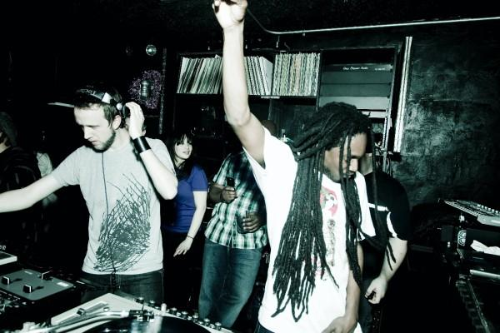
Juakali is a Los Angeles resident, Brooklyn transplant and native of Trinidad and Tobago. He has traveled the world in recent years performing, collaborating with cutting edge artists and igniting audiences in Tokyo, Johannesburg, Amsterdam, Karlovy Vary, Dortmund, Mumbai, to name a few. In 2006, following his FIFA World Cup performances, EGO Magazine described Juakali as an artist "on the forefront of the Reggae, Jungle and burgeoning Dubstep scene in the US and around the world." He is the host of North America's first and premier dubstep event, Dub War in New York City, reviewed and revered by The New York Times, Frank151, URB Magazine, among others. Juakali also brings his talent to Sub Swara, a live electronic crew based in New York City that “deal with the most fascinating melt of sound - beats and bass laced with the elemental voice of Juakali...pure heaven...” (Maryanne Hobbs, BBC Radio 1). As an in-demand vocalist, Juakali has appeared on commercial recordings from Alpha & Omega, Raz Mesani, Pinch, Dub Gabriel and others, impressing both industry and audiences with his ability to innovate across dub, reggae, dubstep, dancehall, bhangra, electronic, and experimental genres. This lead to him being featured as one of the top 5 US Ragga MCs who are, “launching careers as artists and producers… pushing dancehall beyond its boundaries…” (Chat Bout XLR8RR Magazine – Issue118). His debut solo Extended Play release, Breakground on GunJah Records/Foreign Familiar (Winter 2008), integrated Juakali's fresh international aesthetic by incorporating dub, dubstep, and electronic genres with a blend of contemporary and inventive producers. Come From Yard is his latest Extended Play release on Foreign Familiar (Spring 2009), this time including dancehall in his repertoire along with lyrics clearly expressing dissent and those encouraging gratitude, community, and optimism.
www.myspace.com/juakali
www.foreignfamiliar.com
www.surefireagency.com

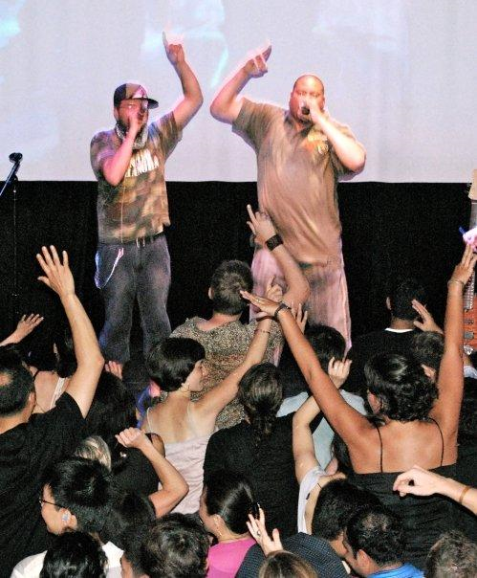
DJ Collage
Since early 2002, the raggamuffin voice of DJ Collage (aka Mr. Chatman) has been a rising sound within the global music community worldwide. His vocal performances have been featured on top releases by artists such as: Dehli2Dublin, Ghislain Poirier, Machinedrum, Filastine, & several others. And as a live performer, he has performed alongside many top names in the reggae world such as: Yellowman, Collie Buddz, Sly & Robbie, Mad Professor and many more. With his recording collaborations and performances, he has been able to bridge the sounds of reggae dancehall to various forms of music such as dubstep, electronica, hip hop and bhangra. Mr Chatman can also be found found performing at sessions such as San Francisco’s Non Stop Bhangra, Dub Mission, and Grime City, Vancouver's Ting, and his Seattle-based Monday night reggae party, Jam Jam.
http://www.myspace.com/djcollage

