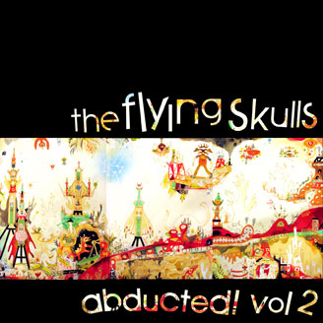

ARTIST: The Flying Skulls
TITLE: Abducted Vol. 2
LABEL: Daly City Records
CAT-NO: DCR144
FORMAT: Digital
RELEASE DATE: 09/29/2009
Of course it was inevitable… that The Flying Skulls and Daly City Records own Mochipet, Vladimir Computin and Preshish Moments would make some seriously f*cked up music together. Looking forward to future projects! The Skulls upcoming remix album Abducted! Vol 2 will be released as a Daly City Exclusive this fall. The Skulls have also announced a three-EP arc that will first drop on Daly City in late 2009.Check your radar good citizens, that blip you see fast approaching is none other than The Flying Skulls, a nu-school production team that plays live improvisational dub-step, breaks, and electro! The group brings the future-soundz of the modern dance music studio and interpolates them through the filter of live improv. With an old school jazz ethos The Skulls combine their tightly-honed electronic and hiphop infused sonic orchestra in a most dirty and crunked-out way. The Flying Skulls first started melting dance floors in April 2008. Originally the brainchild of Lowpro Lounge co-founders Jeff Wareham (J.Tonal) as a way to bring the precision of the recording studio to the dance floor. J.Tonal had been creating music and throwing events in the SF Bay Area for over 7 years, sharing billing with musicians such as DJ Shadow, DJ Krush, Shpongle, Ott, Jack Dangers from Meat Beat Manifesto, and UFO! Straight dope on these Flying Skulls guys? They’re dirty. Dirty beats, dirty grimy low-end, mucked up distorted synthesizers, live syncopated beats flipping between 4/4, 3/4, and 7/8 time. The Skulls distill these elements through their battle-tested mix interface into dancefloor-rending sets of huge beats with a cinematic depth meant for the very largest of soundsystems. Chromekids recently described their sound as, “A heavyweight collection of nasty synths, wobbly basslines and crunked out glitchy beats so dirty you'd swear they robbed their MPC players off a crack dealer.”

Album art by world renown mixed media artist Souther Salazar. http://southersalazar.net

"BBQ Chicken Dub appears courtesy of yo mama"

Tracklisting:
01) Like Magic (Mochipet Remix)
02) Bacon (Ribotto Remix)
03) Snake Charmer - BBQ Chicken Dub Remix (Feat. J.Tonal, Snareface, Jerome & Forney)
04) Money - BBQ Chicken Dub Remix (Feat. J.Tonal, Snareface, & Jerome Forney)
05) Skeleton Talk - BBQ Chicken Dub Remix (Feat. J.Tonal, Snareface, & Jerome Forney)
06) Skulls & Angels (MO2 Remix)
07) Skulls & Angels (Preshish Moments Remix)
08) Trig (Vladimir Computin Remix)

Daly City Records, 353 Philip Dr. #306, Daly City, CA 94015, email: info@dalycityrecords.com

