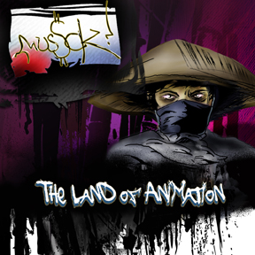
ARTIST: MusSck
TITLE: The Land of Animation
LABEL: Daly City Records
CAT-NO: DCR145
FORMAT: Digital
RELEASE DATE: 01/12/2010

Tracklisting:
01) Creation Of a New World
02) Finding Forever
03) Memory Of Yesterday's
04) Pain To The Picture
05) A Fatherless Child
06) The Core Of The Problem
07) Anger Is Brief Insanity
08) The Mother Of All Mistakes
09) Confession Of A Demon
10) Underworld Of Fortune
11) Ghetto Village In 2D
12) Draw What Comes To Mind
13) Sell You A Dream
14) The Town Made Out Of Clouds

When MusSck was back in high school he use to stay up late at night to watch the series the UK series of Manga classic the fist of the north star as the background music was drum and bass and IDM which got him hooked onto music as well as animation
after collecting heaps loads of animation such as ghost in the shell / death note / ergo proxy / ninja scroll / samurai champloo and street fighter, MusSck always wanted to make music referring to animation and land of animation EP explains all of that

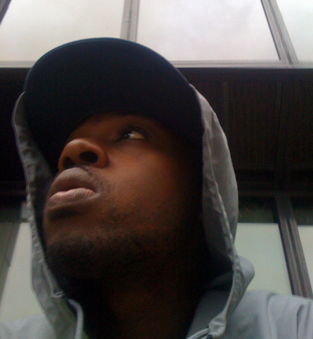

Valance Drakes aka MusSck is up and coming beat maker from London, forming a leading edge of a music style that's unheard of, his sounds takes you into surreal and unknown places with melodies as well as glitch nasty and bass heavy sound
MusSck started his jourey since listening to a prefuse 73 album One Word Extinguisher, he wanted a sound painter but instead of paint he uses an array of sounds with mirco samples and edited beats to include visions of his art, He has created an ecosphere of sounds inside his beats like beauty of the intricate design of nature.

Reviews:

Subtitle (Owner BriEfcAse Rockers. LTD)
mUsScK is slowly becoming the Al Green of the dubstep/IDM underground scene. his soulful chops and wild arrangements add something that's been missing from all this "glitch" music since it's rapid rise to the top and that's SOUL. don't sleep.... he's blazing trails of evil all across the musical world and is becoming the go-to dude for versions and re-edits in a future dubstep processed major way
Myng (Owner of Global Vortex NYC)
Definitely a new breed coming up. MusSck is like a sponge the way he takes information in effortlessly turning it into something amazing. His style is experimental as well as raw as the samples he uses. He is definitely one of the best IDM producers coming up

