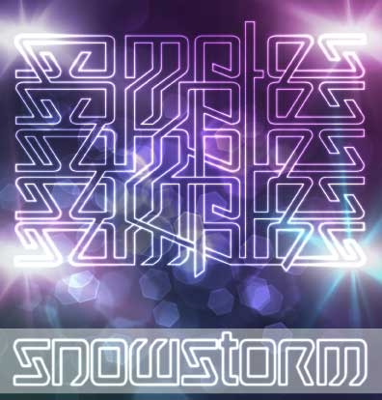

ARTIST: Samples
TITLE: Snowstorm
LABEL: Daly City Records
CAT-NO: DCR151
FORMAT: Digital Release
RELEASE DATE: 05/18/2010

Tracklisting:
1. Snowstorm intro
2. Snowstorm
3. Drop Bombs
4. Smoking Barrel
5. Here We Go
6. Digitalis

(Ben) Samples is one half of the live remix project Fresh2Death that is based out of Boulder, CO. His style is crunk glitch-hop, complete with bass-heavy remixes of your favorite club anthems and hip hop. His professional DJ career started in 2006 when he picked up a weekly variety radio show for CU Boulder's KVCU. His show covered many styles and genres, with a focus on dance music and hip hop. Now, Samples blends both hip hop and dance music into a hybrid club hip hop sound that is redefining the genres. Samples is a member of the Denver Bass Squad, which is the essential crew that pushes the heavy bass-line scene in the Denver/Boulder area, including a residency at the world-famous Beta night club.

Websites:
http://www.bensamples.com
http://samples.bandcamp.com
http://www.myspace.com/bensamplesmusic
http://www.soundcloud.com/bensamples
http://twitter.com/djsamples

