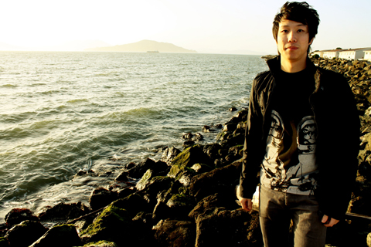

Lokae Biography

Few electronic producers can meld frenetic, danceable rhythms with introspective song progressions. Lokae manages to do so effortlessly. Bubbling in the Bay Area’s underground electronic community, producer and multi-instrumentalist Lokae (Ian Luo) makes it his mission to move the listener – slaying the dance floor or rocking the theater of your mind, he’s happy with either result.

Originally from China, raised in Southern California, and now currently residing in San Francisco, Luo has developed a far-reaching appreciation for diverse musical backgrounds and styles. He has played classical piano, got his chops down with jazz ensembles, nodded his head for years to the boom bap, and honed techniques of collage while DJing throughout the Bay Area. Such a broad musical background helps inform the pliancy in Lokae’s production strategy, where he brings visceral instrumentation to bear on laptop robotics. His live performance infuses a cutting-edge Ableton set with dynamic improvisatory skills – where you can see Luo triggering percussive loops, manipulating effects, and layering keyboards on the fly. It’s a talent fit to make any introvert shake around in a frenzy and induce extroverts to have just a moment of thoughtfulness. Expect some heat from this promising beat conductor.

Links:

http://www.lokaemusic.com
http://www.soundcloud.com/lokae
http://www.facebook.com/lokae
http://www.myspace.com/lokae0
http://www.twitter.com/lokae

