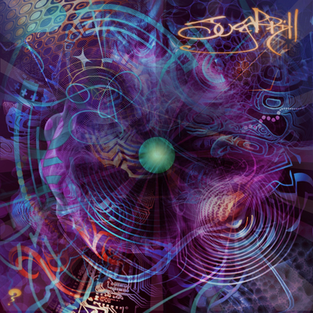

ARTIST: Sugarpill
TITLE: Sugarpill Flow Goggles
LABEL: Daly City Records
CAT-NO: DCR155
FORMAT: Digital Release
RELEASE DATE: 09/21/2010

Specializing in bouncing bass, sideways beats and experiments of noise, Sugarpill is a master of both the creation and delivery of polytemponic glitch. Residing in Los Angeles yet living in a twisted world of sound, this young artist stays dosed to the eyelids in chopped-up samples, meticulously tweaked beats and obese waves of bass. Sugarpill seamlessly merges his techy sensibility and immaculate production skills without ever losing the inherent sexiness of the beats, and this multidimensional musical approach unite EDM fans across a vast spectrum of genres and tempos. His original tracks combined with explosive live DJ sets confirm for the producer a powerful spot at the forefront of West Coast future sound. Crossing genres effortlessly and employing a rich variety of styles, his lively and intense sound is best described as a party- and that is exactly what Sugarpill brings to the dance floor.

Tracklisting:
1. Some Say The
2. Flow Goggles
3. Paper Bounce
4. Disconnect Your Elbows
5. Soul Like A

