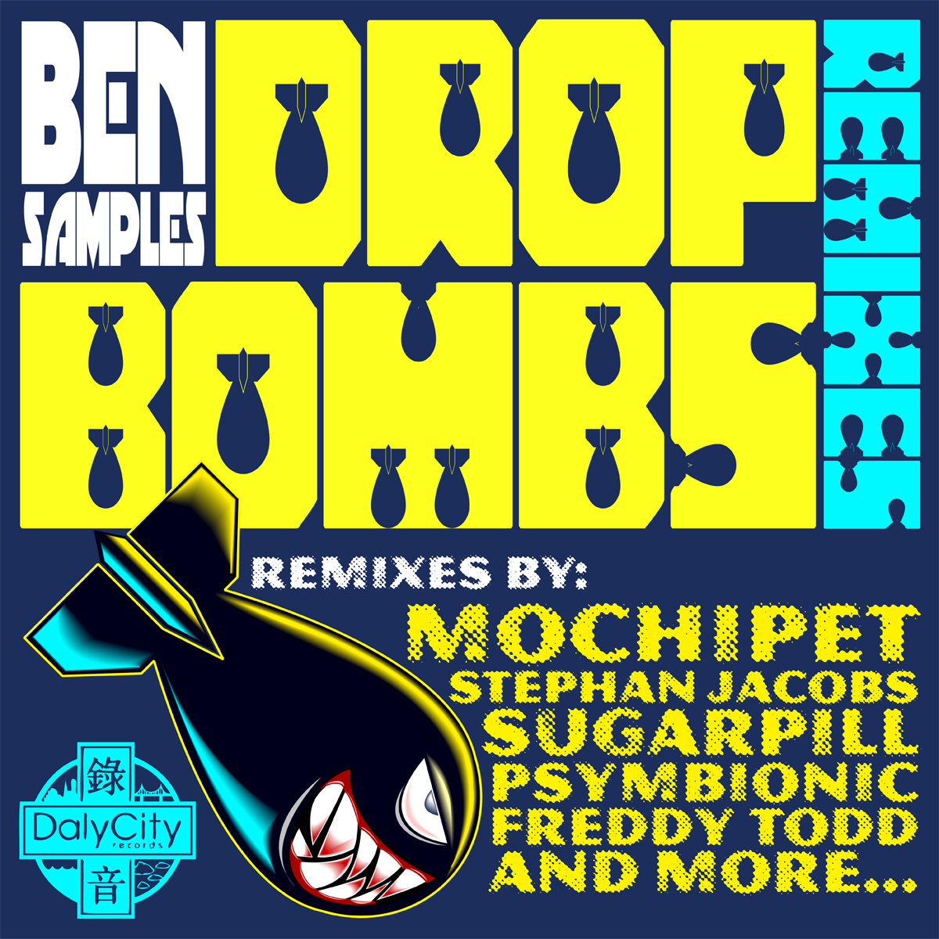

ARTIST: Samples
TITLE: Drop Bombs The Remixes
LABEL: Daly City Records
CAT-NO: DCR159
FORMAT: Digital Release
RELEASE DATE: 02/22/2011

Since the release of Ben Sample’s chart toping “Snowstorm” album last year, on Daly City Records, it is obvious that the bass grinding track “Drop Bombs” has been a staple in the glitch-hop and heavy bass communities. It is only fair that a remix album followed. With remixes by Mochipet, Freddy Todd, Sovereign Sect, Stephan Jacobs, Psymbionic, Chris B, Sugarpill, Dan K, and Samples himself there is more then enough for everyone! These remixes range between the 80-140bpm range; but all of them contain very heavy bass lines and jaw dropping builds. Ready to detonate any sub-woofers in its path, the Drop Bombs Remixes should NOT be played in the Chill Room! *why don’t they do chill rooms anymore?

Tracklisting:
Drop Bombs (Mochipet Remix)
Drop Bombs (Samples VIP Remix)
Drop Bombs (Freddy Todd Remix)
Drop Bombs (Sovereign Sect Remix)
Drop Bombs (Stephan Jacobs Remix)
Drop Bombs (Psymbionic Remix)
Drop Bombs (Chris B Remix)
Drop Bombs (Sugarpill Remix)
Drop Bombs (Dan K Remix)

