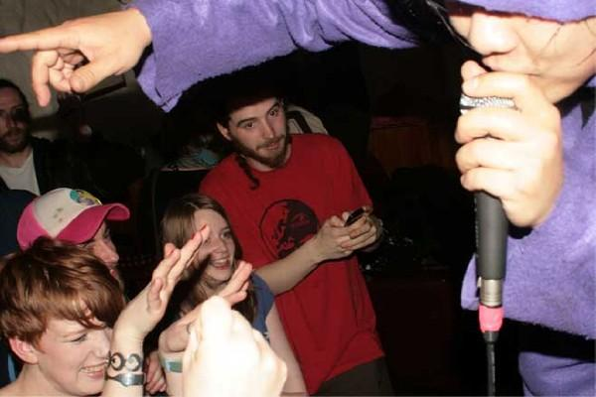

Mochipet Tech Requirements:
- Stereo 1/4" DI input or DJ mixer with 1/4" or RCA Stereo Line inputs
- 1 microphone (preferably with an on/off switch)
- 2' x 3' of table space 32" preferably high or taller (2' x4' if the setup includes a DJ mixer)
- Some type of Monitoring System with level control (preferably Mackie SRM-450 or equivalent)
- Bangin' Sound (not required but preferably with at least one 18" Sub woofer or multiple 15" Sub woofers for most mid sized venues)
- For performances in the Dino Dragon Suit, a fan is required so Mochipet does not overheat.

